Assembly Recommendations.
Lever Gap: There is an unexpected gap when the lever support aluminum part is assembled. To eliminate this gap follow the procedures below.

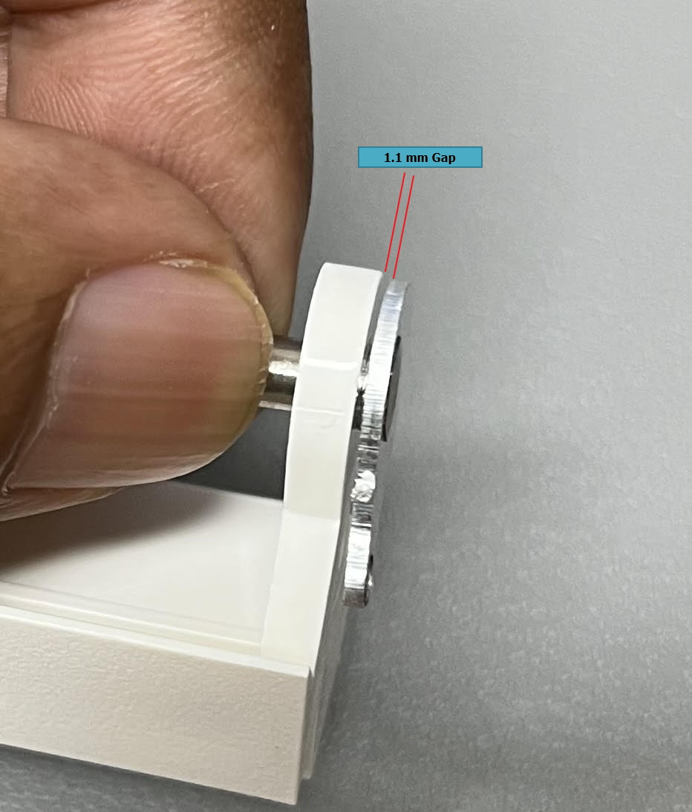

Tapper Peel Off: Use a cutting tool like a proper diameter drill bit to peel off a tapper portion from the plastic part as below.

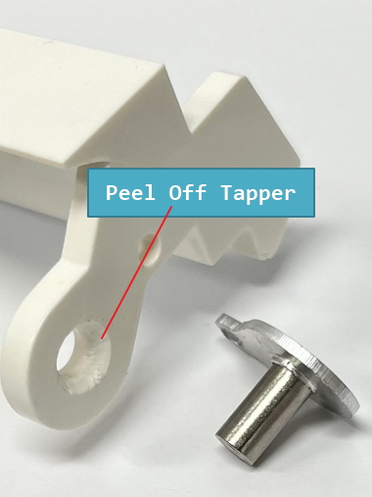

Fit Lever Part: Now it is fit properly without any gap between.

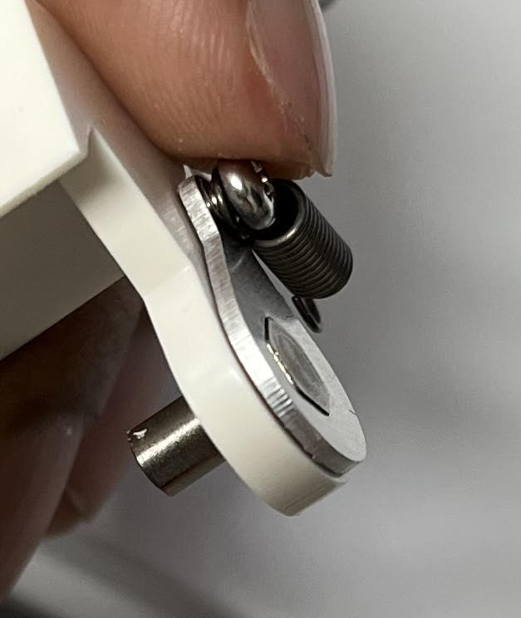

Printer Cartridge Eject Lever Assembly:

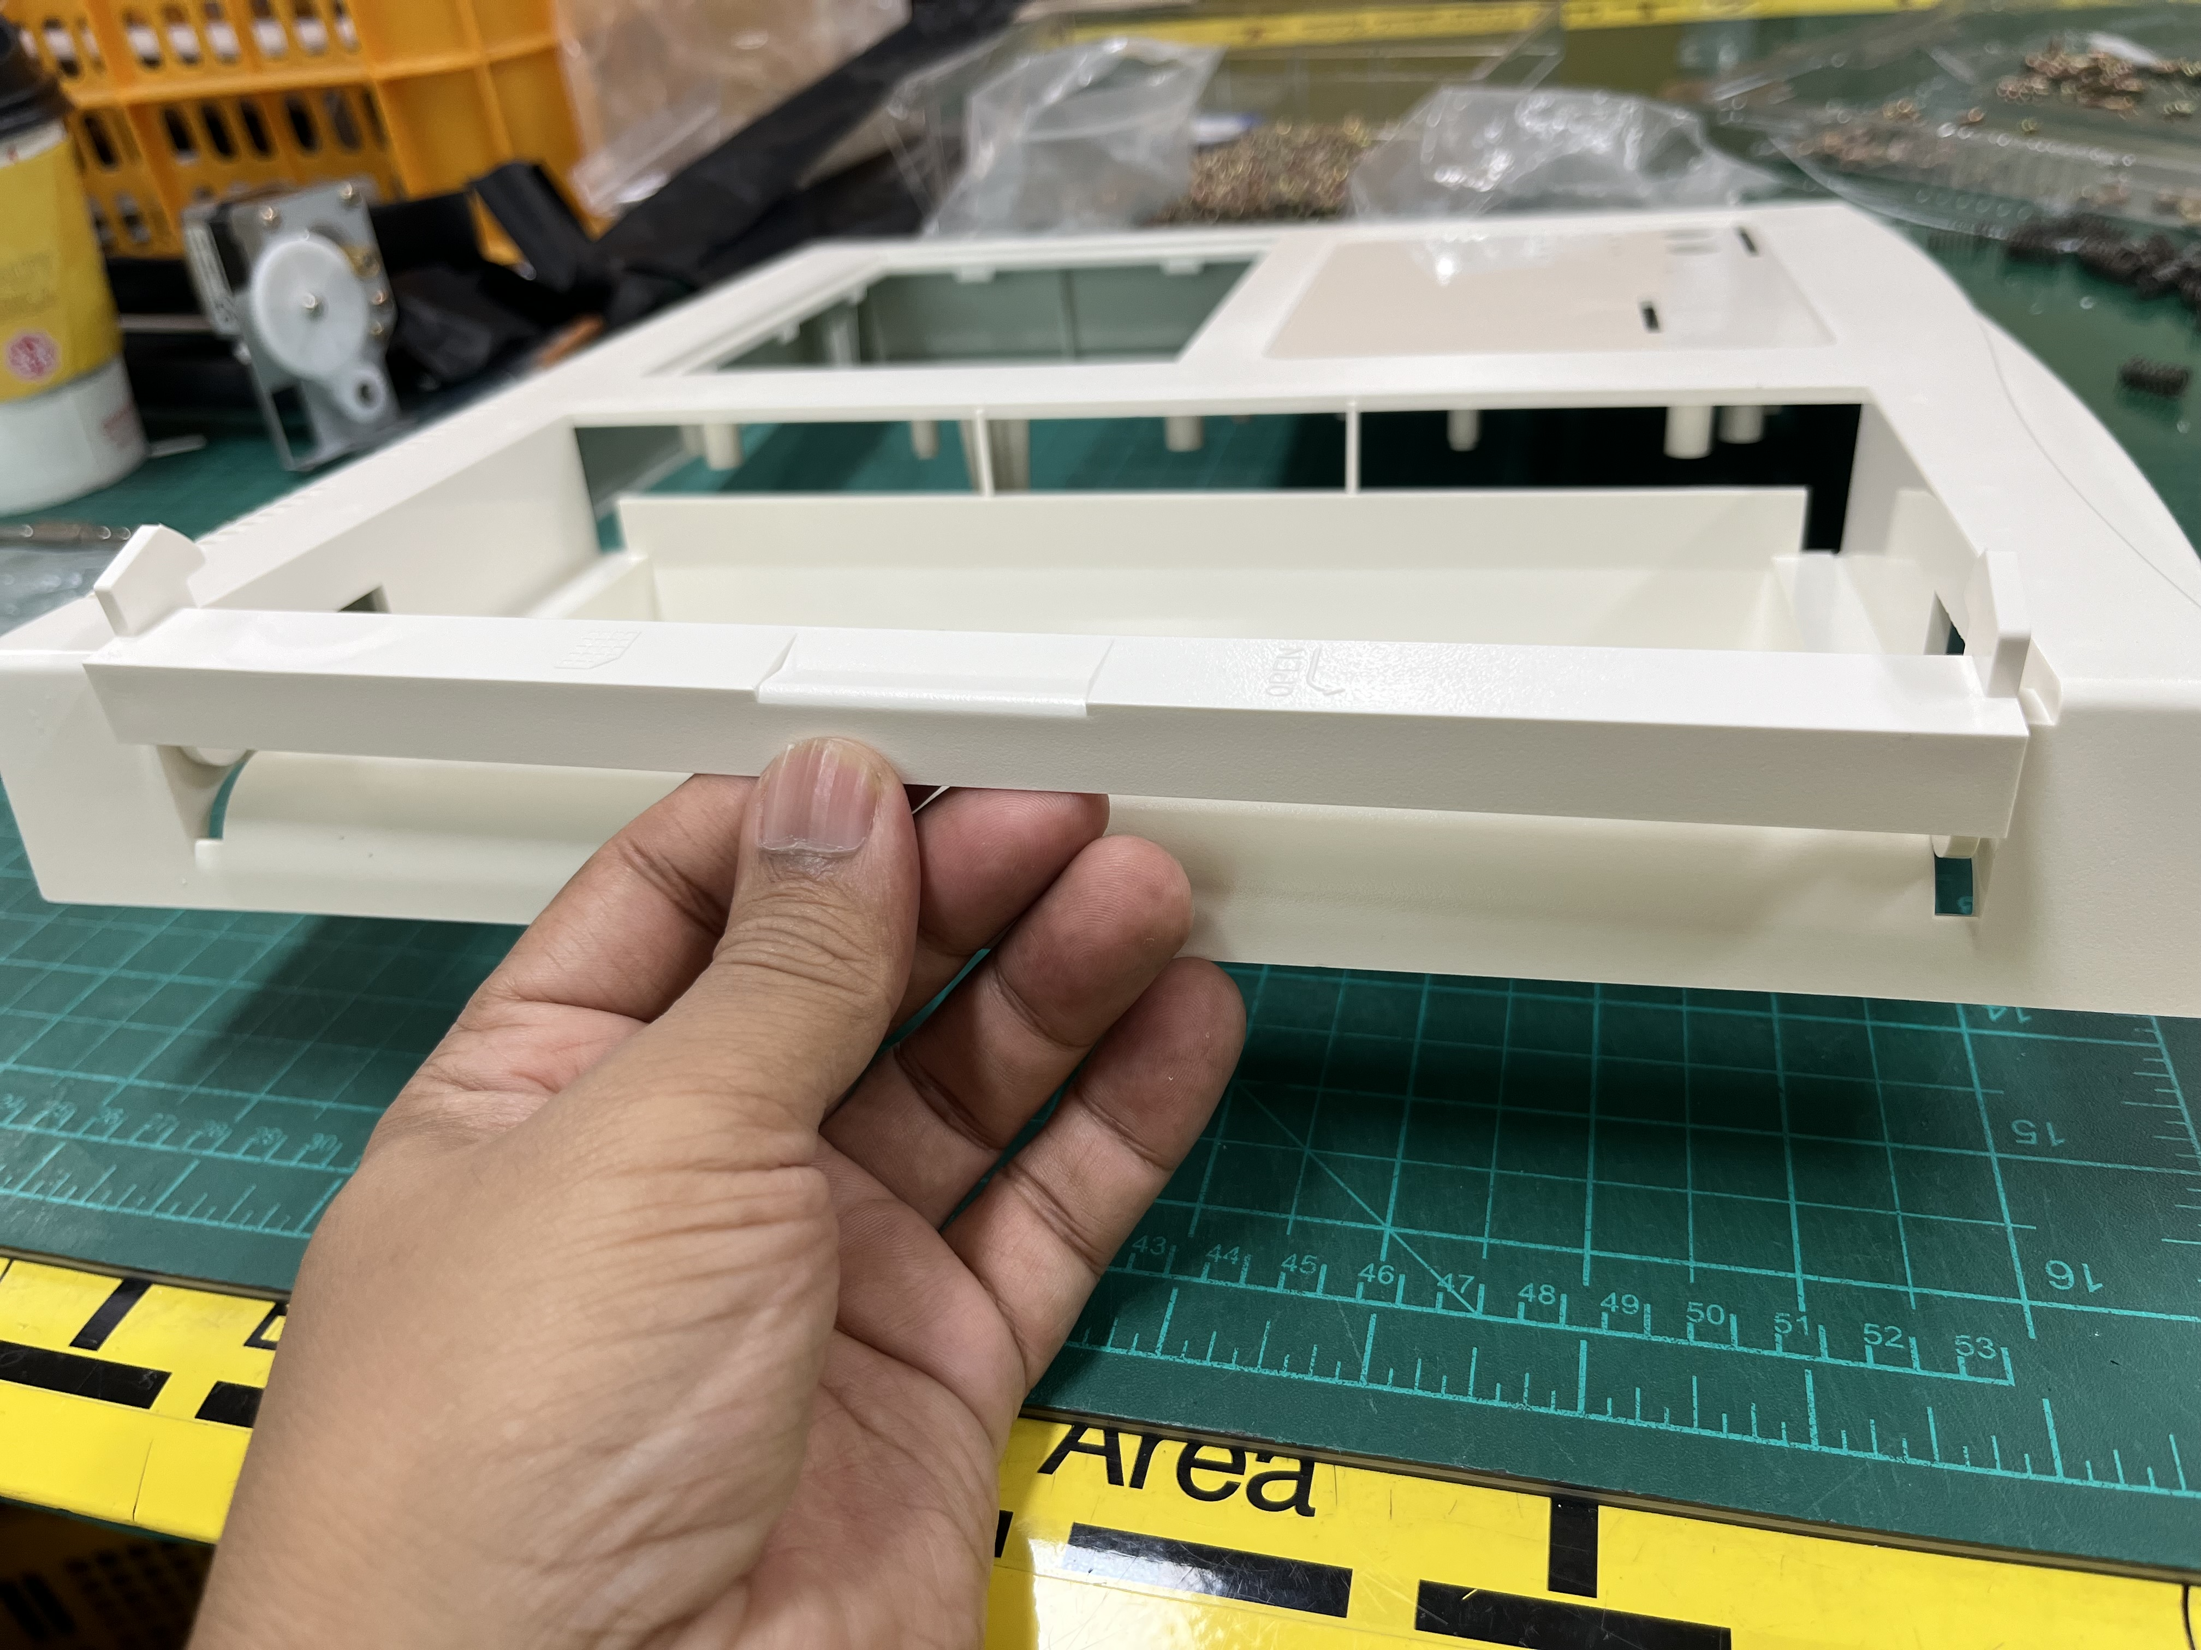

Insert two 3x10 Self Tapping screw to both sides as below:

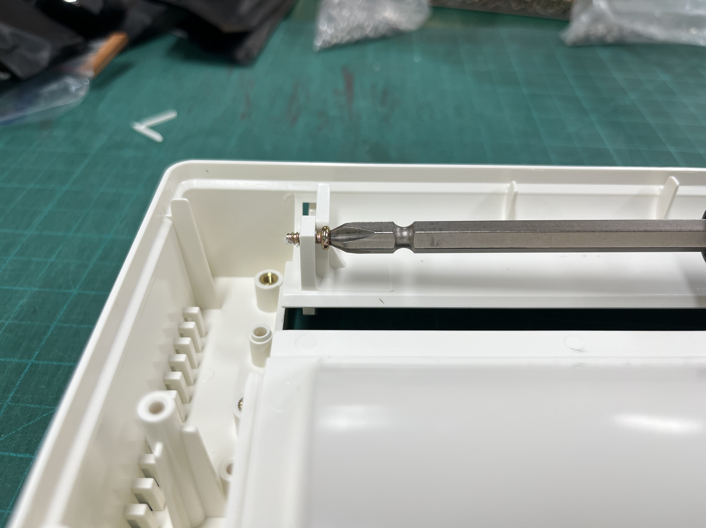

Connect the Lever Support Tension Spring on both sides as shown below with a proper tool.



